|  |  |
| --- | --- |
| **Practicum Case** |  |
| CPEN6098 | CPEN6108 | CPEN6109  Computer Networks |
| **Computer Engineering** | **O1-CPEN6098-HP01** |
| ***Valid on*** *Even Semester Year 2019/2020* | **Revision 00** |

## Learning Outcomes

* Describe basic structures of network
* Explain basic concepts of network

## Topic

* Session 04 - Routing Techniques

## Sub Topics

* Routing Concepts
* Static Routing Basic
* Static Routing Advanced

## Soal

*Case*

**Experiment Activity 1 (Static Routing Basic)**

1. Create two networks as the picture below (can use simulation in Packet Tracer)

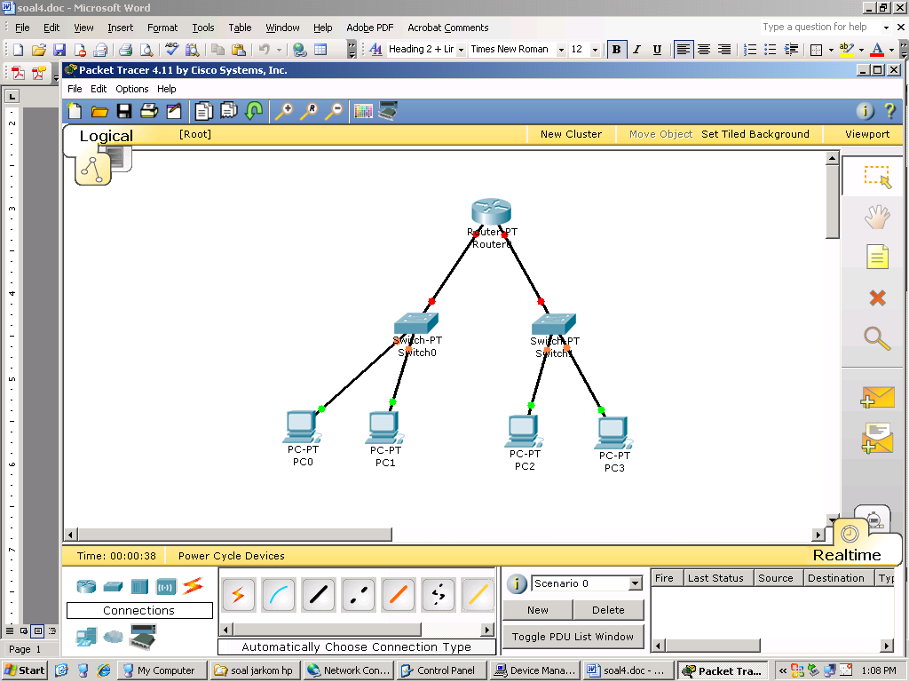

**Network Information:**

**PC:**

* IP PC0 : 192.168.1.2/24
* IP PC1 : 192.168.1.3/24
* IP PC2 : 192.168.2.2/24
* IP PC3 : 192.168.2.3/24

**RouterA**

* IP FastEthernet 0/0 : 192.168.1.1/24
* IP FastEthernet 1/0 : 192.168.2.1/24
* IP Serial 2/0 : 192.168.3.1/24

1. Settings the PC Router with the following steps:
   1. Input

**Username : prk**

**Password : prk**

* 1. Input the command “**telnet localhost 2601**”
  2. Input the password: zebra
  3. Input the syntax

Router>enable

Router#configure terminal

Router(config)#hostname "bluejack" (*optional*)

bluejack(config)#interface eth0

bluejack(config-if)#ip address 192.168.3.1/24

bluejack(config-if)#no shutdown

bluejack(config-if)#exit

bluejack(config)#interface eth1

bluejack(config-if)#ip address 192.168.1.1/24

bluejack(config-if)#no shutdown

bluejack(config-if)#exit

bluejack(config)#interface eth2

bluejack(config-if)#ip address 192.168.2.1/24

bluejack(config-if)#no shutdown

bluejack(config-if)#exit

bluejack(config)#ip forwarding

bluejack(config)#exit

bluejack#exit

* 1. After that exit from putty, change the ip of each computer according to predefined ip above.
  2. Finally, try to do a ping between computers.

**Experiment Activity 2 (Static Routing Advanced)**

1. Create a network with 2 router based on picture below (can use simulation in Packet Tracer)

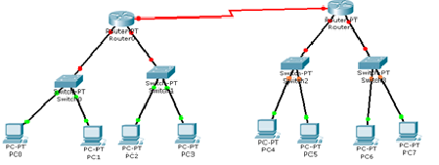

**Network Information:**

Network on the left router is already set in experiment activity 1.

**PC**

* IP PC4 : 192.168.4.2/24
* IP PC5 : 192.168.4.3/24
* IP PC6 : 192.168.5.2/24
* IP PC7 : 192.168.5.3/24

**Router B** (right side)

* IP FastEthernet 0/0 : 192.168.4.1/24 (eth1)
* IP FastEthernet 1/0 : 192.168.5.1/24 (eth2)
* IP Serial 2/0 : 192.168.3.2/24 (eth0)

**Here are the steps required to configure static routing:**

1. Set all IP address.
2. Configure in Router A (left side router) :

**RouterA(config)#ip route 192.168.4.0 255.255.255.0 192.168.3.2**

**RouterA(config)#ip route 192.168.5.0 255.255.255.0 192.168.3.2**

**RouterA(config)#ip forwarding**

1. Configure in Router B (right side router):

**RouterB(config)#ip route 192.168.1.0 255.255.255.0 192.168.3.1**

**RouterB(config)#ip route 192.168.2.0 255.255.255.0 192.168.3.1**

**RouterB(config)#ip forwarding**

**If you don’t understand, please ask to your assistant!**